Finesse Test

Set Gadgets:

HOST vpn: IE devnetsb02.cisco.com

Login FastLab-Finesse-001

PW LAGA9UCB

Finesse API Resource:

http://<Finesse_FQDN>:8082/finesse/api/SystemInfo

when input API Mang Postman app Get Rest for:

<http://hq-uccx01.abc.inc:8082/finesse/api/SystemInfo> the following image below shows up

If the request is successful, you should get a HTTP status of 200 OK and see some XML formatted data with the status of the Finesse system

Finesse Molina Team

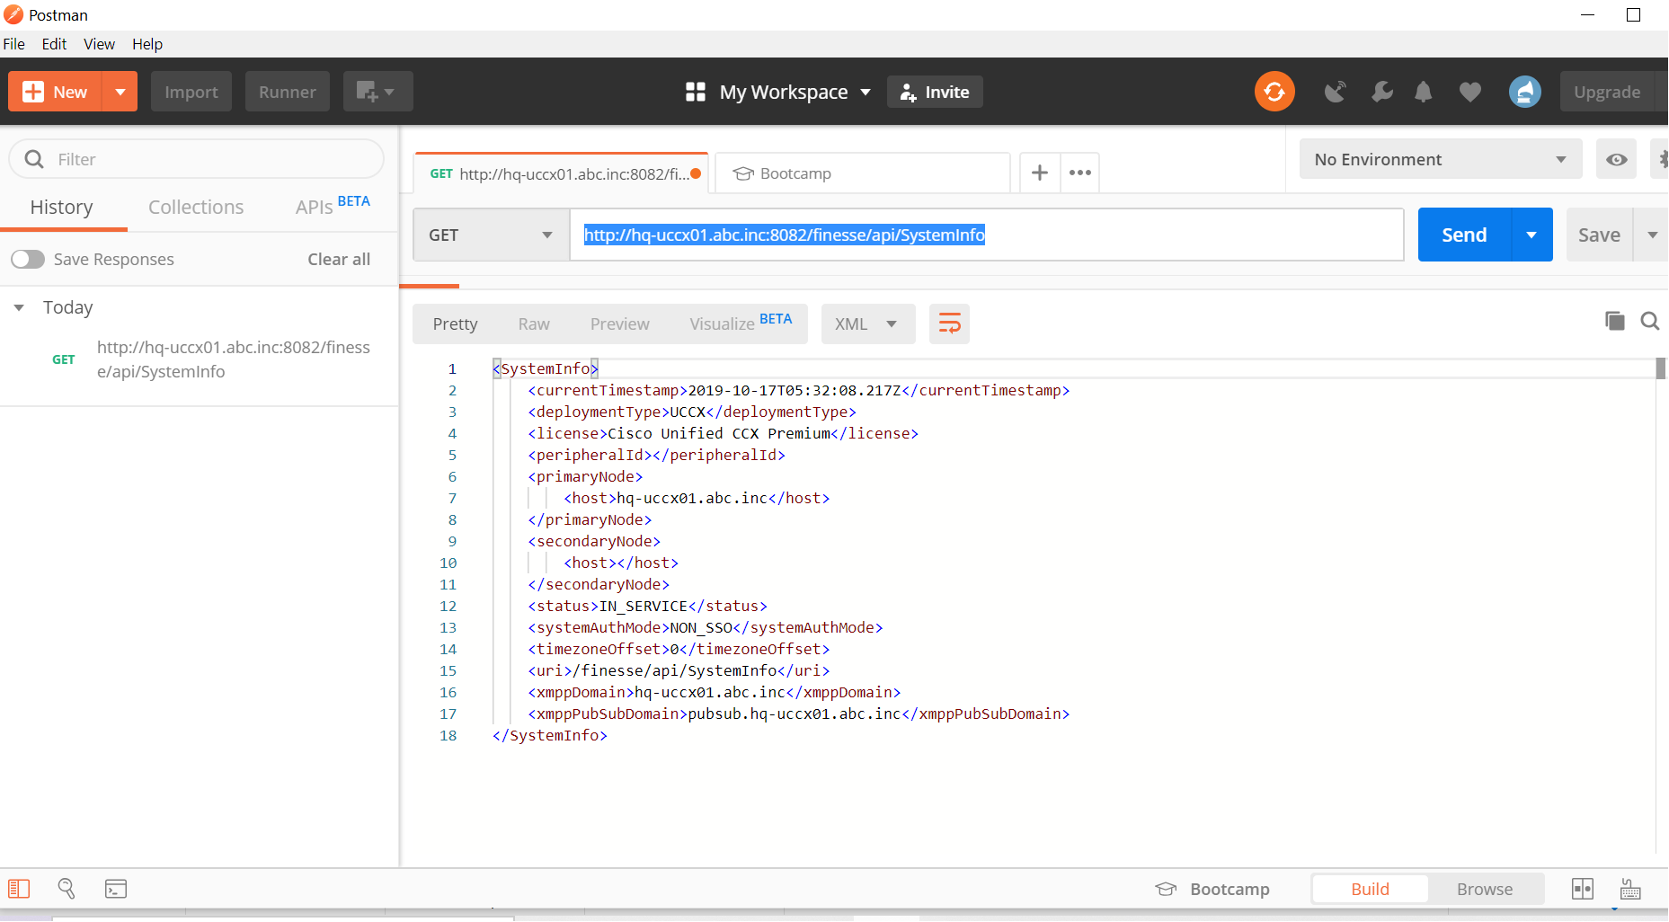

This info above includes peripheral ID which in Finesse is tied to Peripheral Gateway how?

In chrome after opening API Request SystemInfo as above

Go to for example Pidgin Messenger

UserName user001

Password cisco1234

Extension 5001 which signs userA to receive finesse notifications

<https://xmpp.org/software/libraries.html> for production

